**SPI Slave with Single Port RAM**

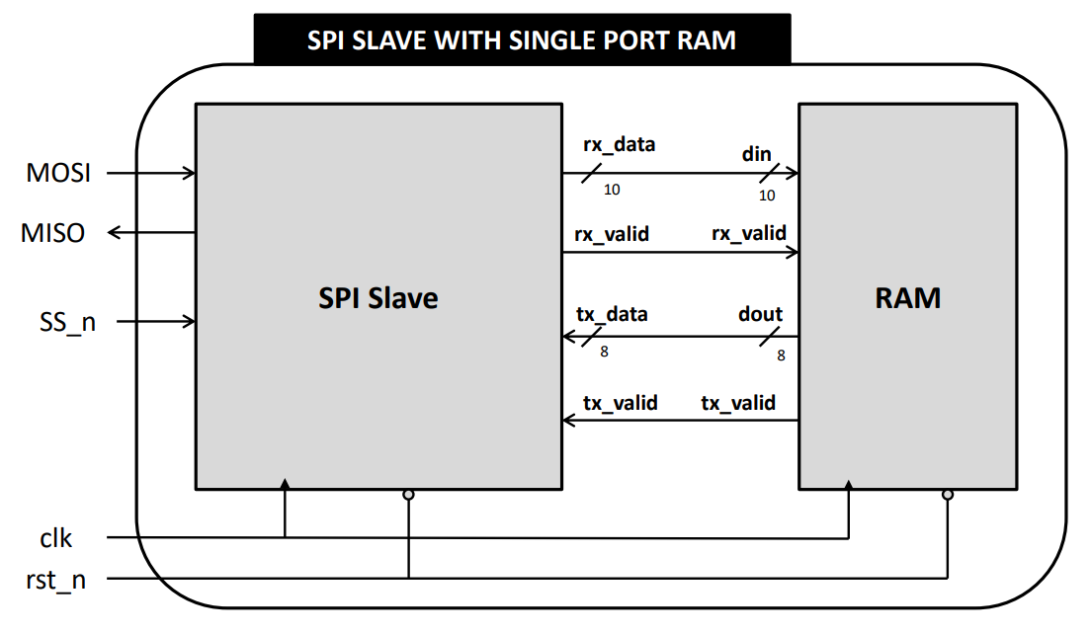

p

**Prepared by: Mohamed Shaban Moussa**

**Submitted to: Eng. Kareem Waseem**

**Prepared by:** Mohamed Shaban Moussa

**📧 Contact**

* **Email:** [**mohamedmouse066@gmail.com**](mailto:mohamedmouse066@gmail.com)
* **Linkedin:** [**Press Here**](www.linkedin.com/in/mohamed-s-moussa-ba0993285)

**📁 Project Sources:** 📎[Press here](https://github.com/mohamedSmoussa/SPI-Slave-with-Single-Port-RAM-)

SPI Wrapper RTL code

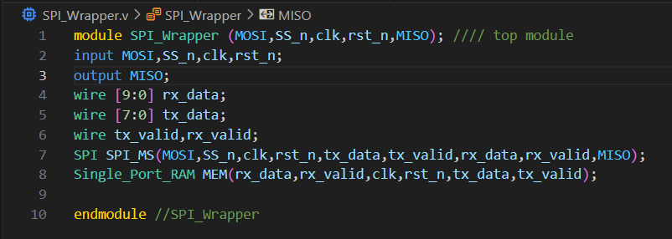

Single Port RAM RTL code

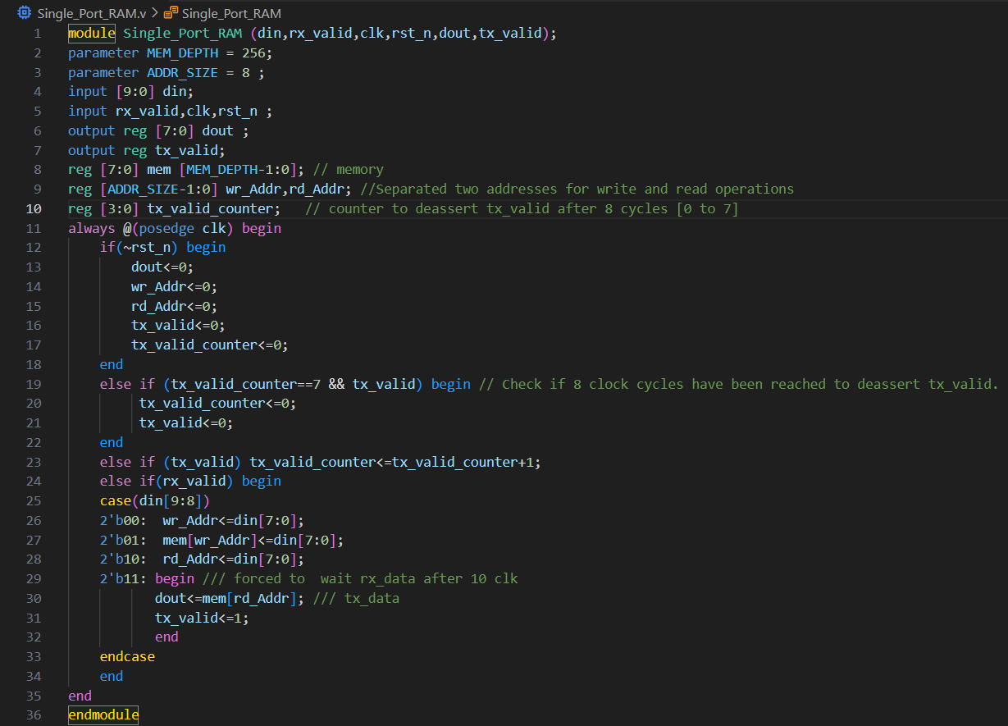

States Definitions And State Memory Block Block

SPI Protocol RTL code

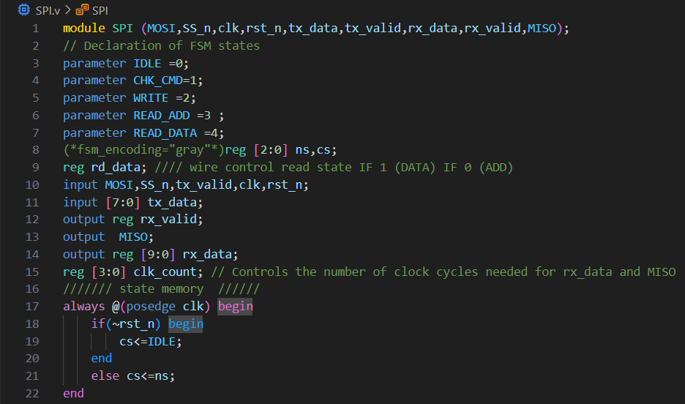

* **rd_data: Control signal that determines if reading data (1) or address (0)**
* **clk_count: 4-bit counter to track clock cycles**

**for rx_data and MISO operations**

Next State Logic Block

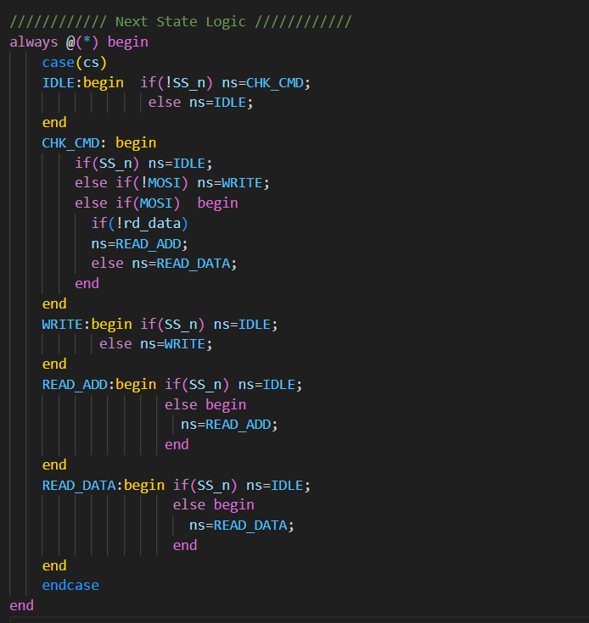

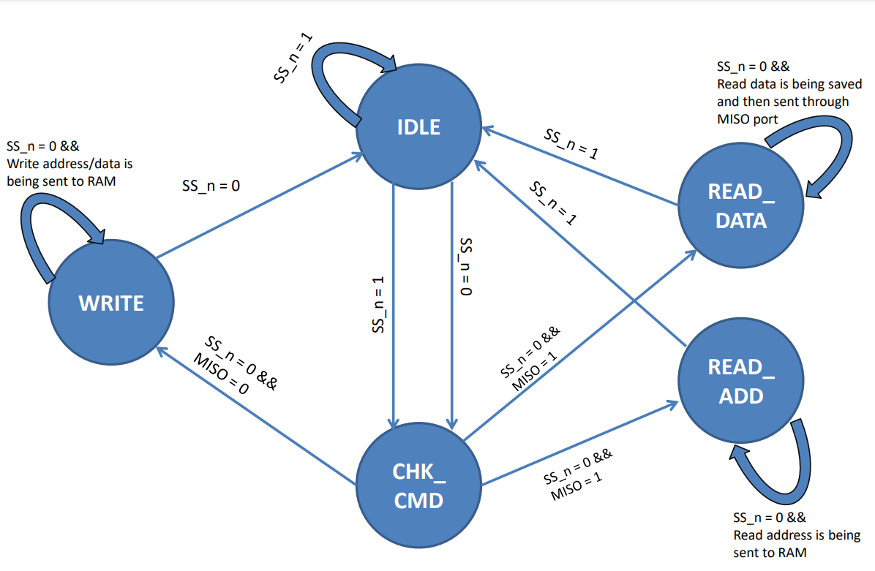

Output Logic Block

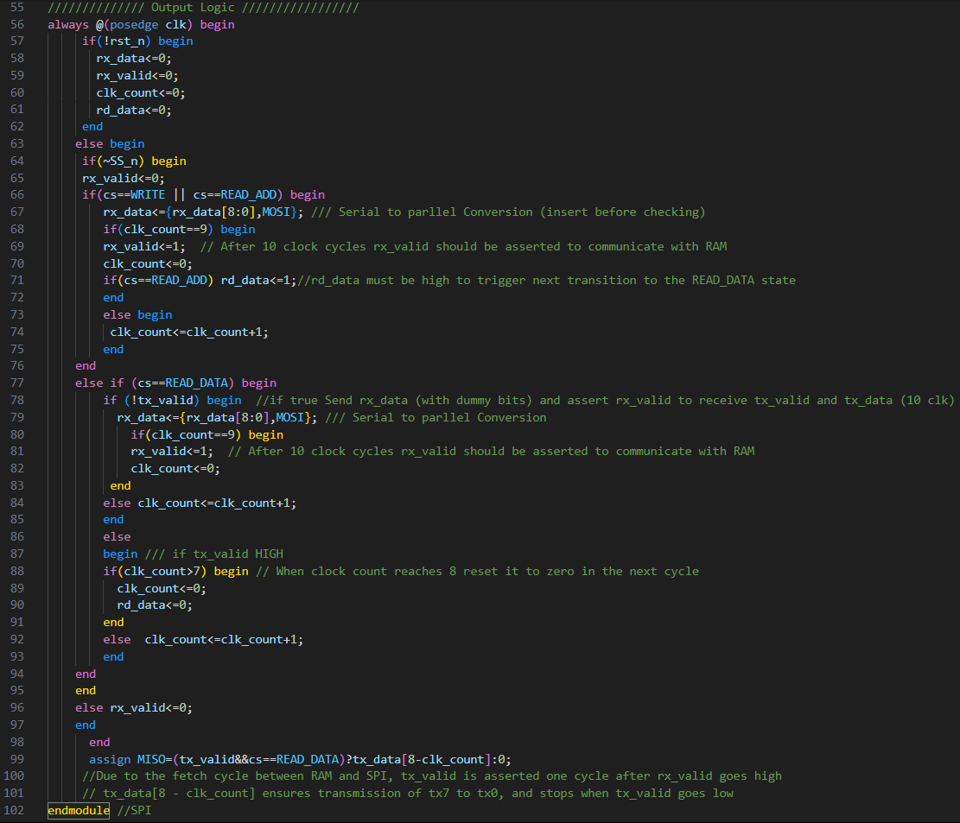

Clock Generation And Apply rst_n

SPI Wrapper Testbench code

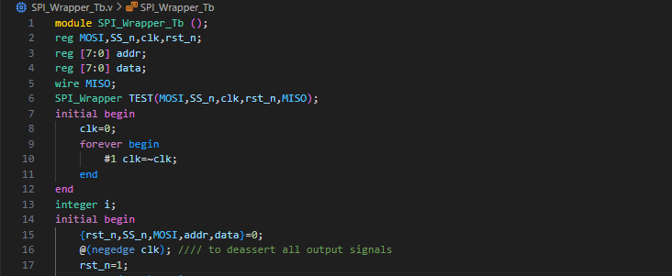

Briefly describe the code flow and what data and addr do

**Phase 1: Send Address (Write Address Command)**

1. **SS_n = 0 → Start communication.**
2. **MOSI = 0, wait 2 falling edges of clk → To reach WRITE state (1 for CHK_CMD, 1 for WRITE).**
3. **Wait 2 more falling edges → Set rx_data[9:8] = 2'b00 → This is "Write Address" command.**
4. **Loop 8 cycles:**
   * **Send 8-bit address bit-by-bit on MOSI.**
   * **Bits are stored in addr[7:0].**
5. **SS_n = 1 → End communication. Wait 1 clock cycle → Slave fetches addr into internal memory.**

**Phase 2: Send Data (Write Data Command)**

1. **SS_n = 0, MOSI = 0 → Start communication again.**
2. **Wait 2 clock cycles → To reach WRITE state.**
3. **Send rx_data[9]=0 and rx_data[8]=1 → Command becomes 2'b01, which is "Write Data".**
4. **Loop 8 cycles:**
   * **Send 8-bit data on MOSI.**
   * **Bits are stored in data[7:0].**
5. **SS_n = 1 → End communication,Wait 1 clock cycle → Slave stores data into memory at addr.**

**Phase 3: Read by Address (Read Address Command)**

1. **SS_n = 0, MOSI = 1 → Start communication again.**
2. **Wait 2 clock cycles → To reach READ_ADDR state.**
3. **Send rx_data[9]=1 and rx_data[8]=0 → Command is 2'b10, "Read Address".**
4. **Loop 8 cycles:**
   * **Send back stored addr[7:0] on MOSI.**
   * **Slave receives it and uses it as read address.**
5. **SS_n = 1 → End communication.**
6. **Wait 1 clock → Slave fetches data from memory at the given address.**

**Phase 4: Receive Data (Read Data Command)**

1. **SS_n = 0, MOSI = 1, wait 2 clocks → Enter READ_DATA state.**
2. **Send rx_data[9:8] = 2'b11 → Read Data command.**
3. **Send 8 dummy bits on MOSI just to allow clock edges.**
4. **Wait 1 clock → Slave loads tx_data with stored data.**
5. **Loop 8 cycles:**
   * **Master reads MISO bit-by-bit.**
   * **Each MISO bit is compared to data[7:0].**
   * **If mismatch → Display error and stop simulation.**
6. **SS_n = 1 → End communication.**
7. **Wait 1 clock.**
8. **After loop ends → $stop is called to finish simulation.**

**The code is repeated 2000 times to ensure thorough testing of all address and data combinations through multiple SPI transactions.**

Self-Checking Testbench (Repeat 2000 times)

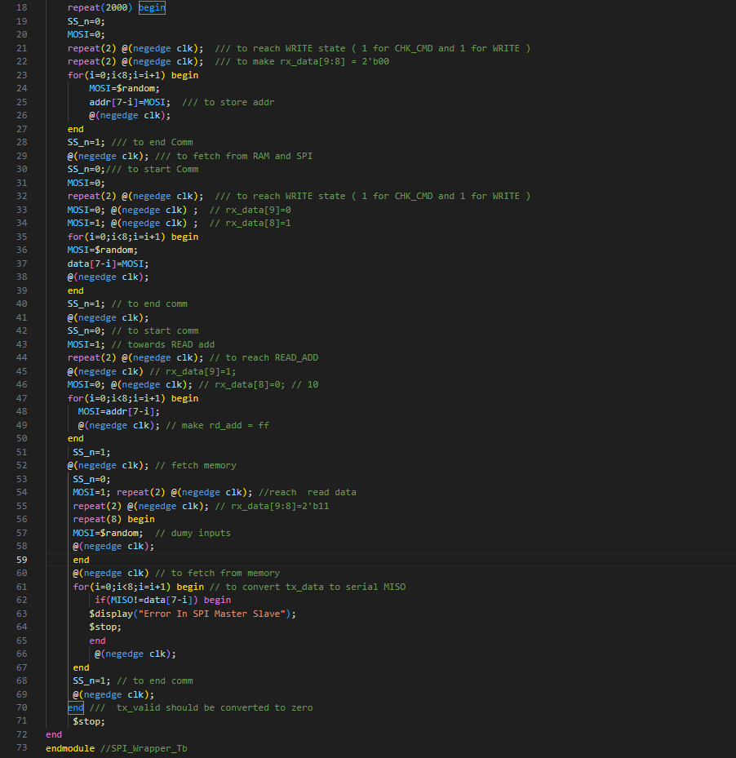

SPI Wrapper do File

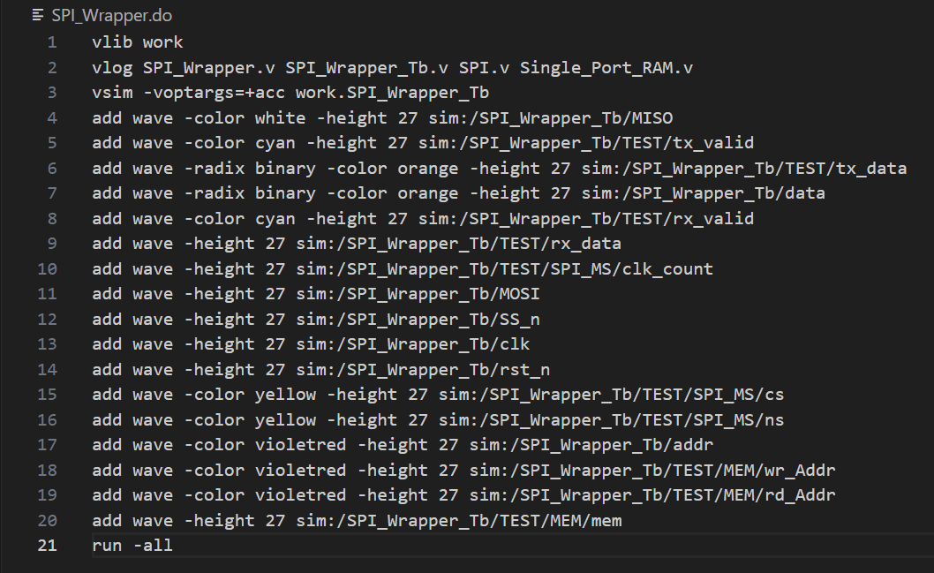

|  |  |
| --- | --- |
| **Signal order** | **Signal Color** |
| **MISO** | **WHITE** |
| **tx_valid** | **cyan** |
| **tx_data** | **orange** |
| **data** | **orange** |
| **rx_valid** | **cyan** |
| **rx_data** | **Normal** |
| **clk_count** | **Normal** |
| **MOSI** | **Normal** |
| **SS_n** | **Normal** |
| **clk** | **Normal** |
| **rst_n** | **Normal** |
| **cs** | **yellow** |
| **ns** | **yellow** |
| **addr** | **violet** |
| **wr_Addr** | **violet** |
| **rd_Addr** | **violet** |
| **mem** | **Normal** |

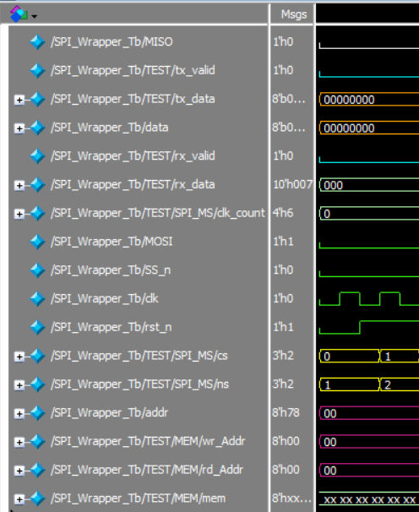

SPI Wrapper Wave Forms

**Note: I implemented a tx_valid_counter alongside a single-port RAM to ensure that tx_valid is asserted only for 8 clock cycles during transmission as we see**

First Check

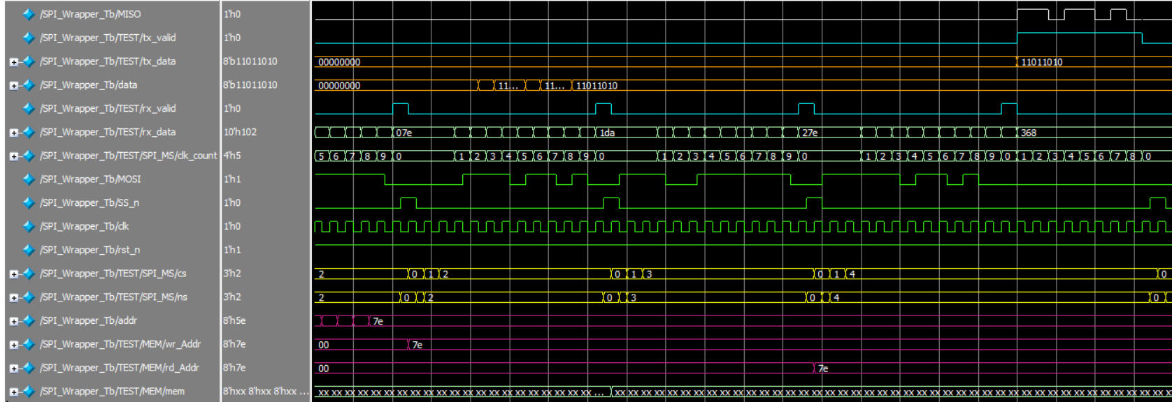

Second Check

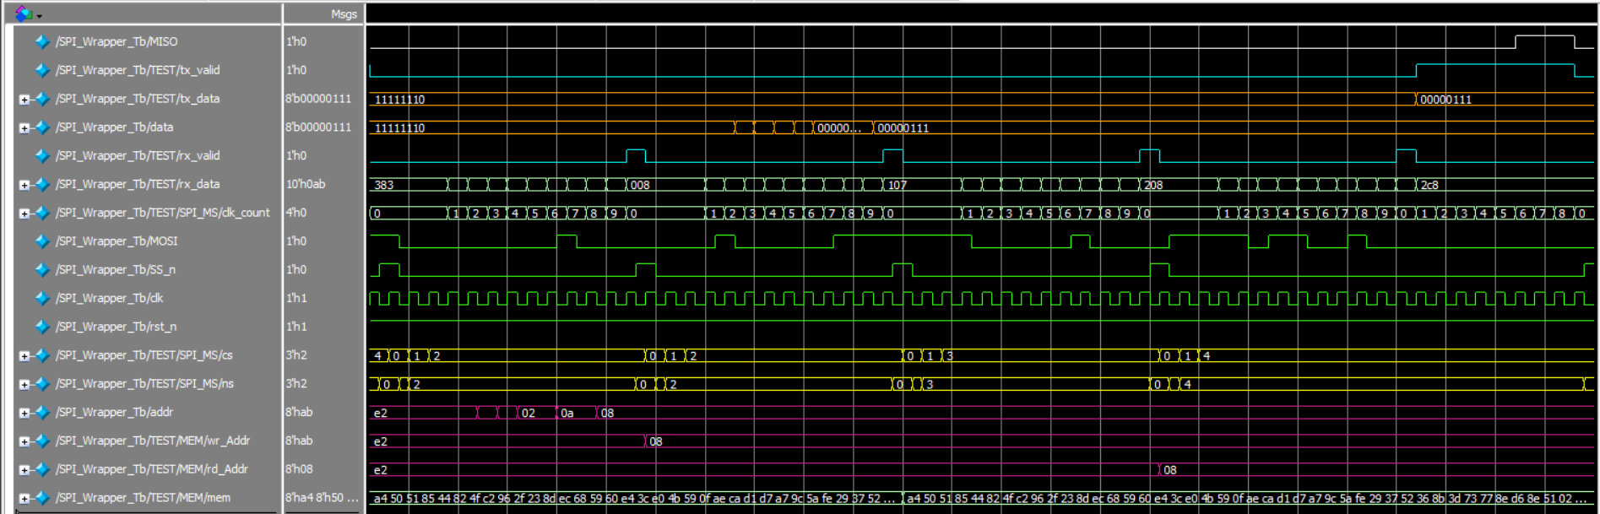

Third Check

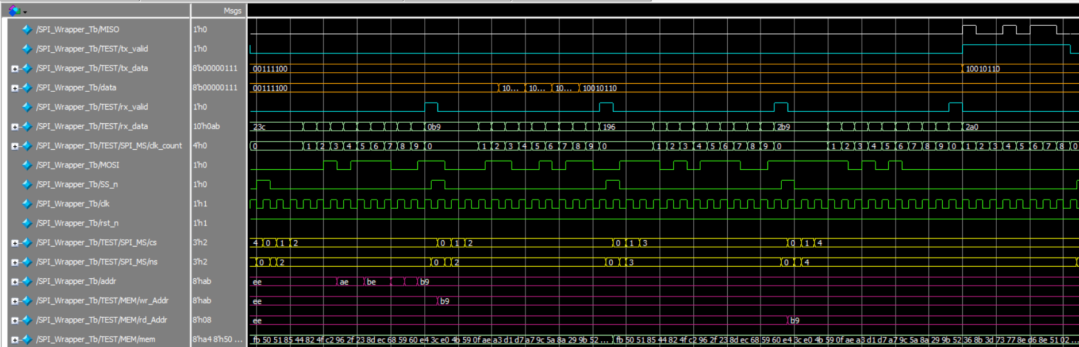

Multiple Checks

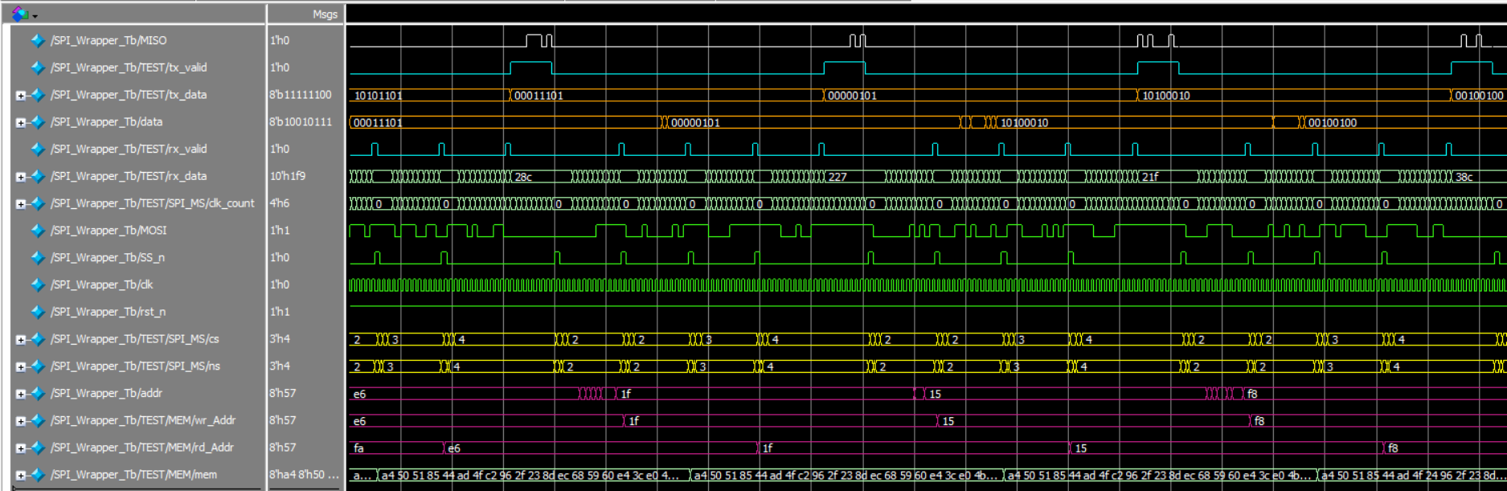

Memory Contents After 2000 Operation

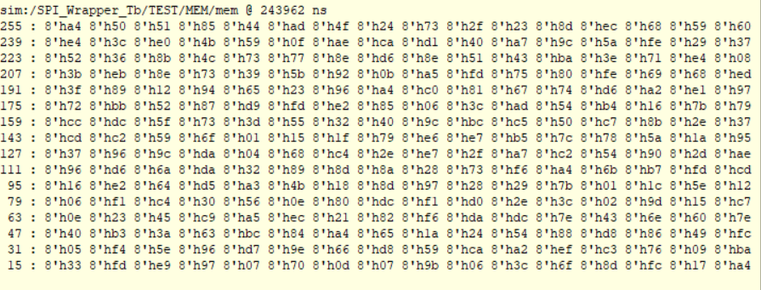

Qlint Snippet (No Errors)

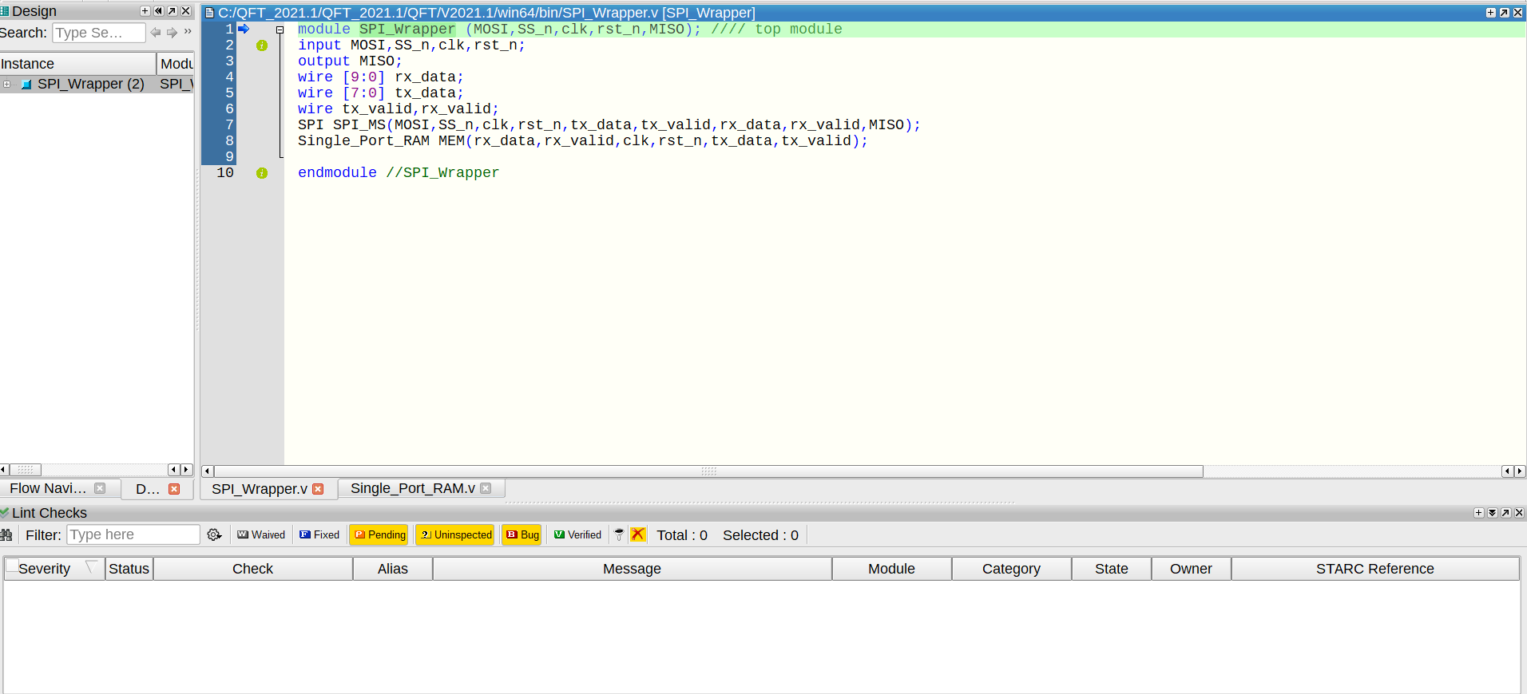

RTL Schematic

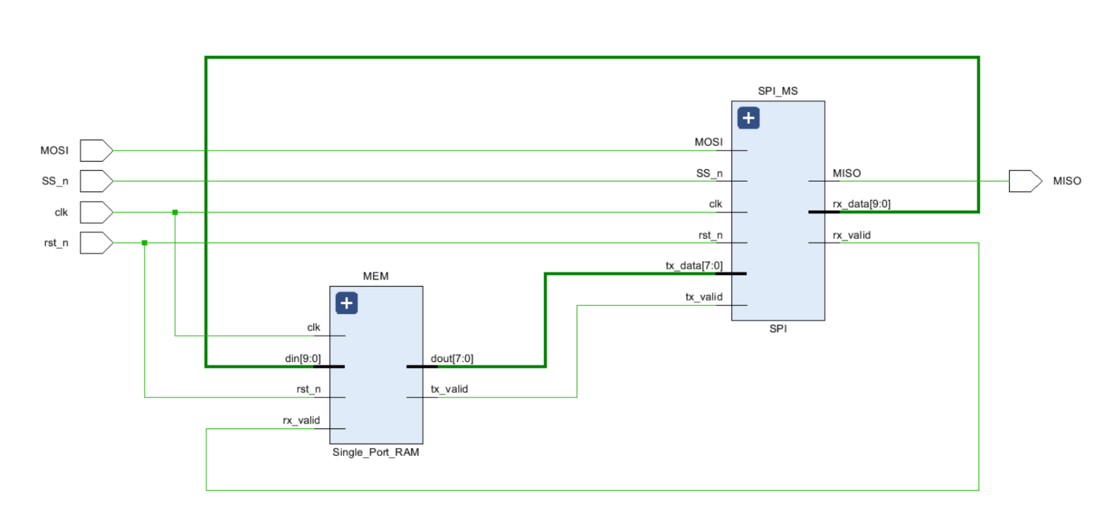

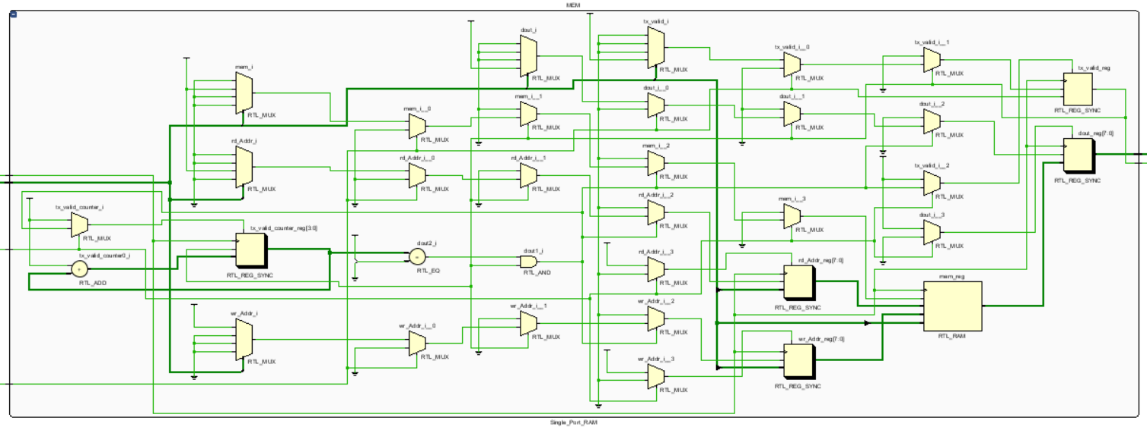

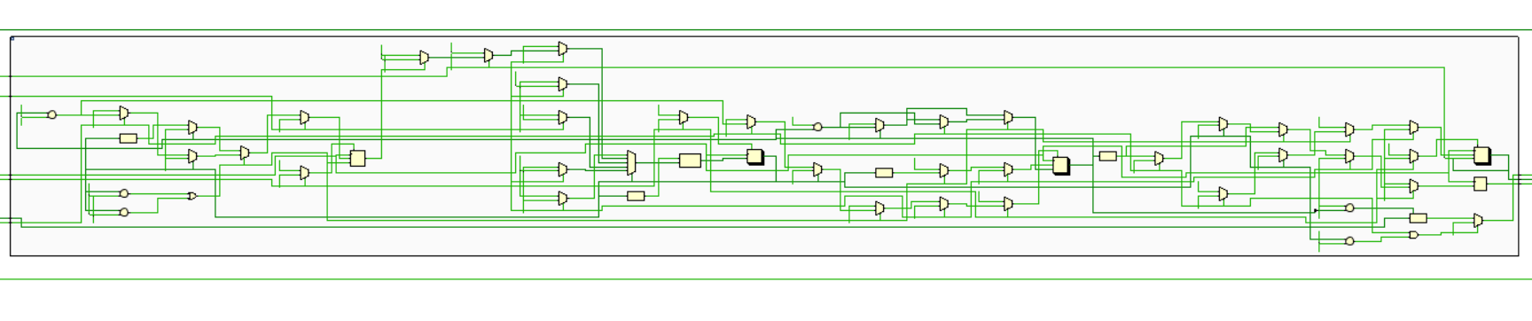

RTL Schematic Messages

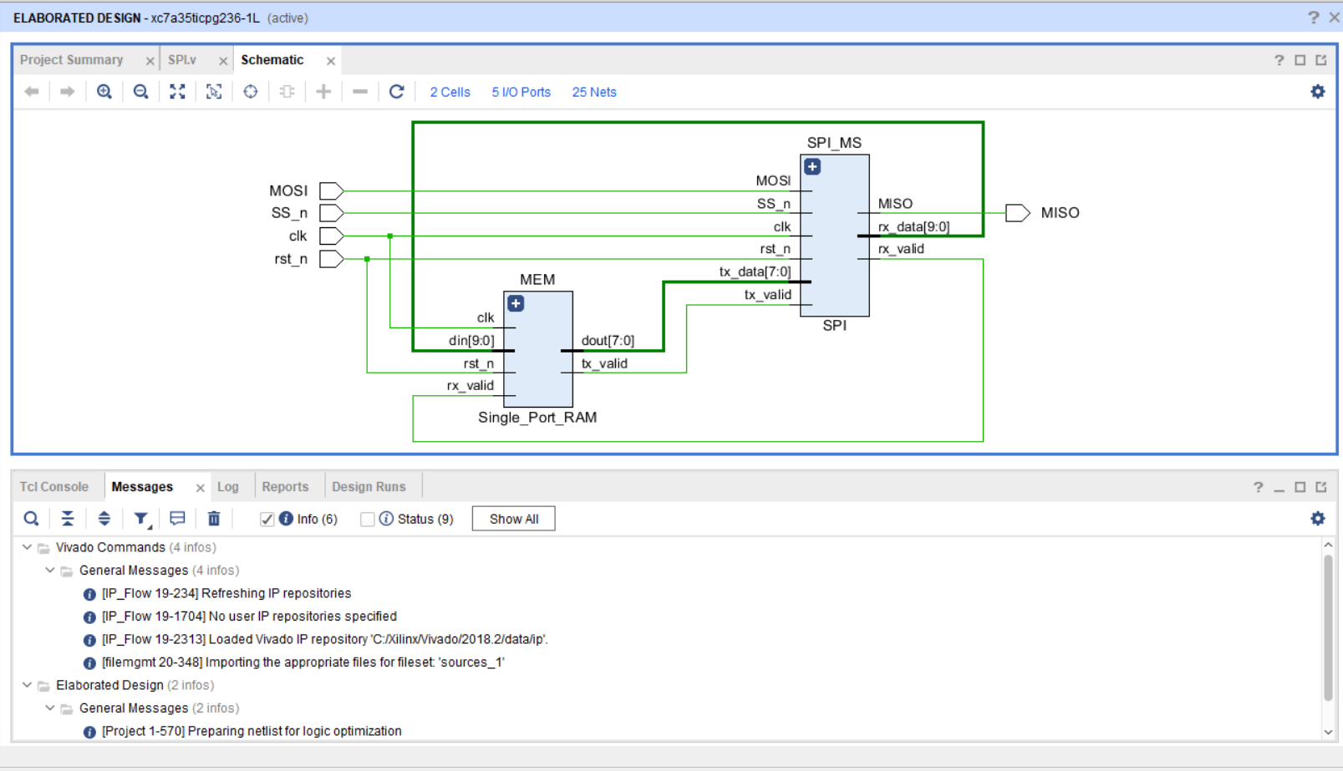

**Note :RTL schematic is the same for three different encoding methods**

Sequential Encoding

Encoding Report

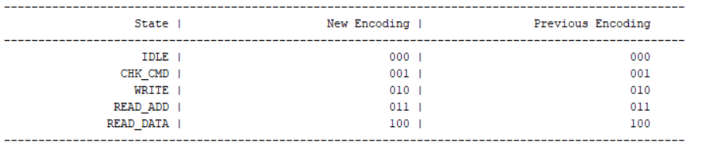

Synthesis Schematic

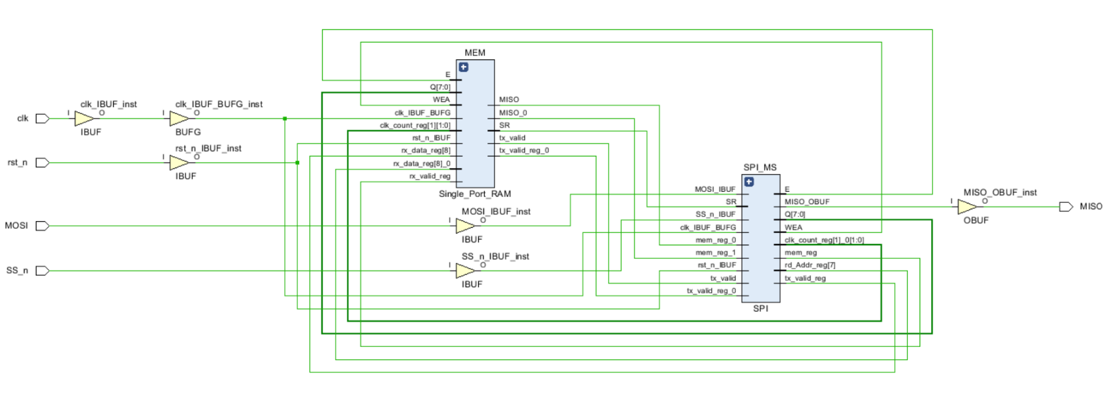

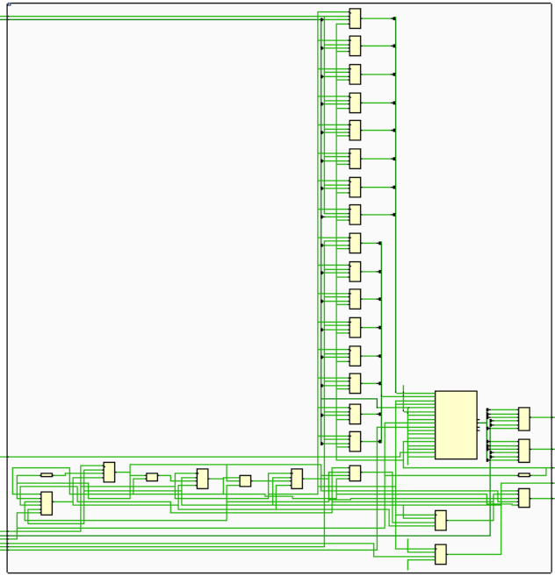 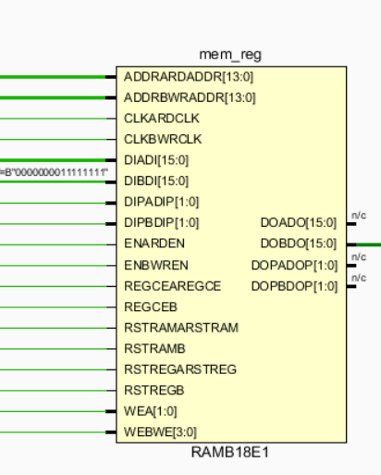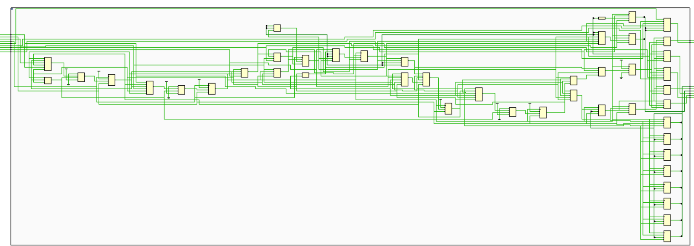

Synthesis Messages Tab

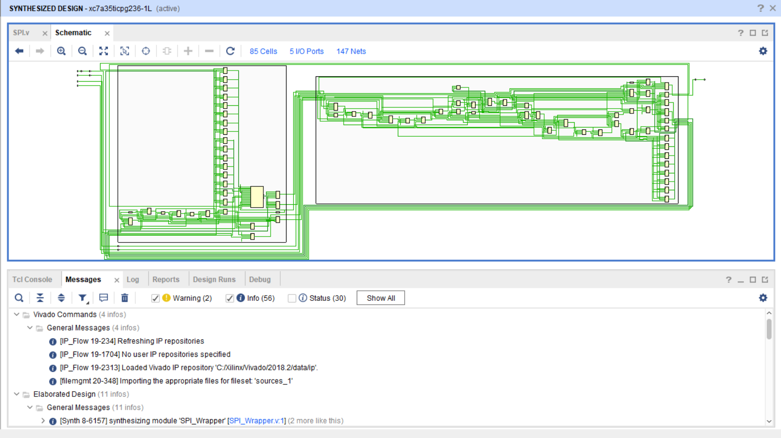

Synthesis Utilization & Timing Reports

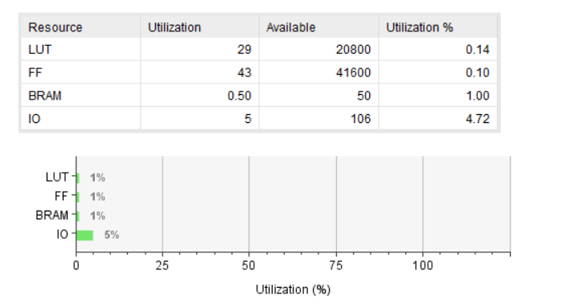

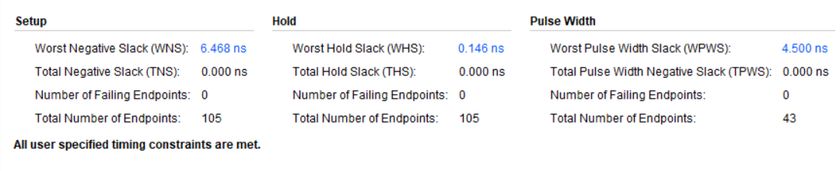

Synthesis Critical Path

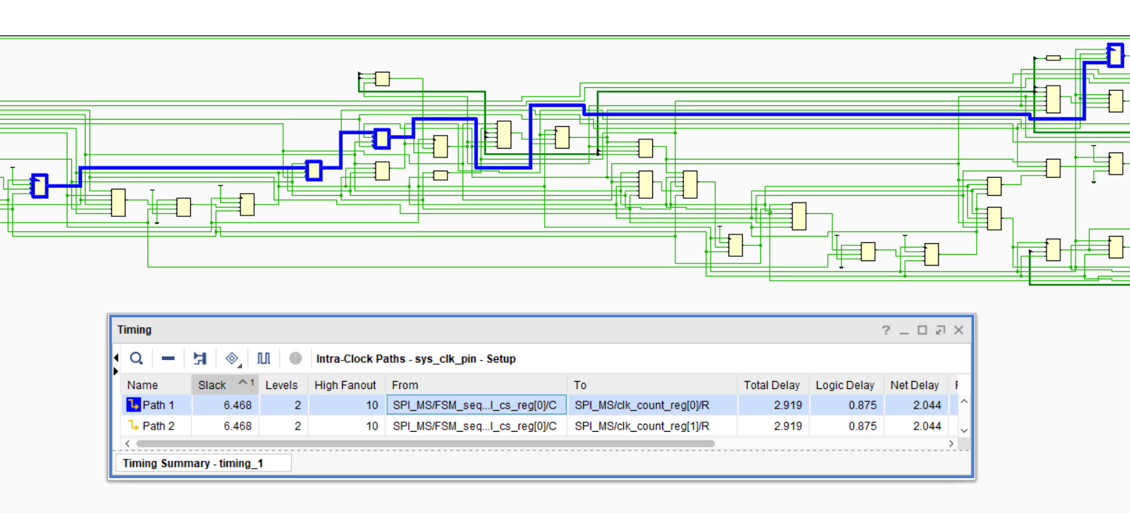

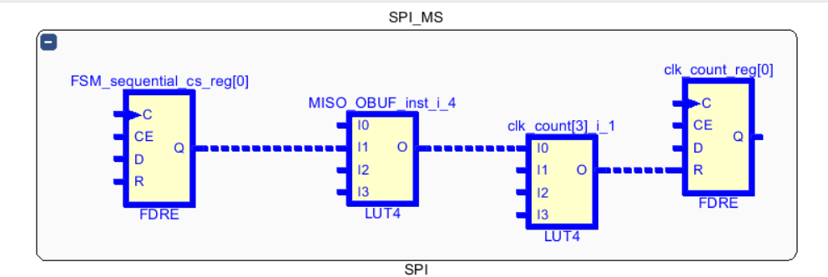

Implementation Messages Tab

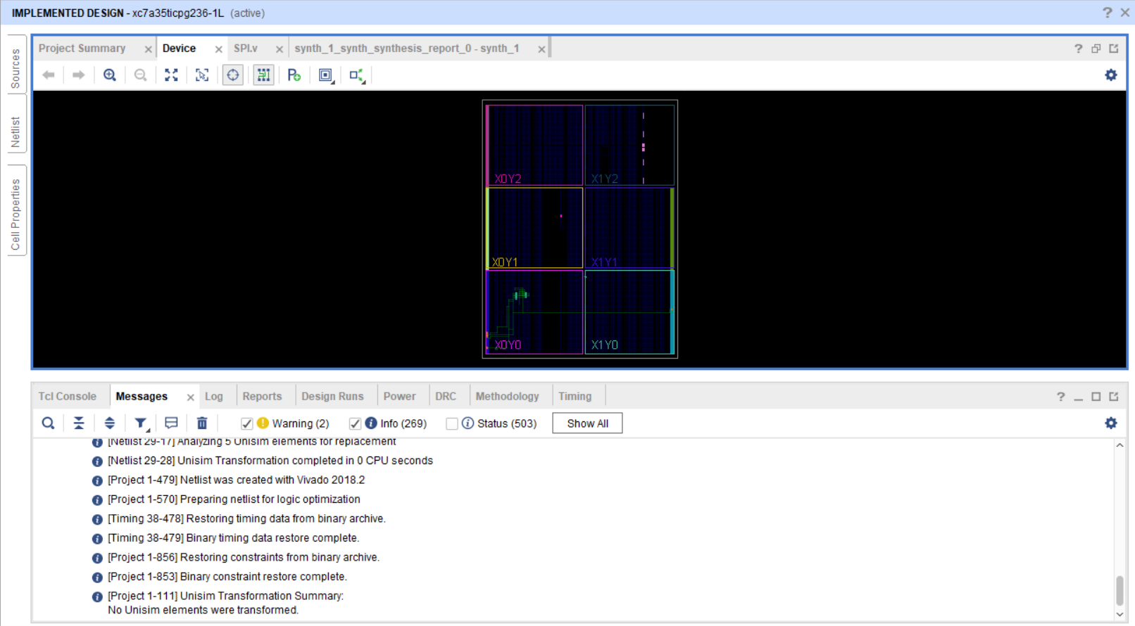

Implementation Device

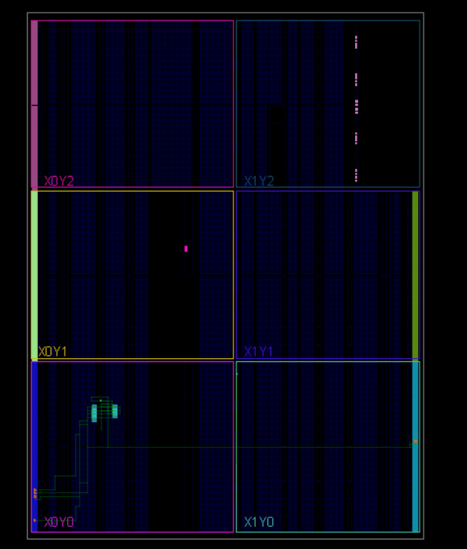

Implementation Utilization & Timing Reports

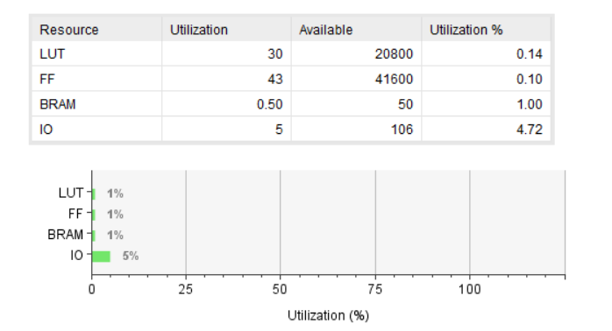

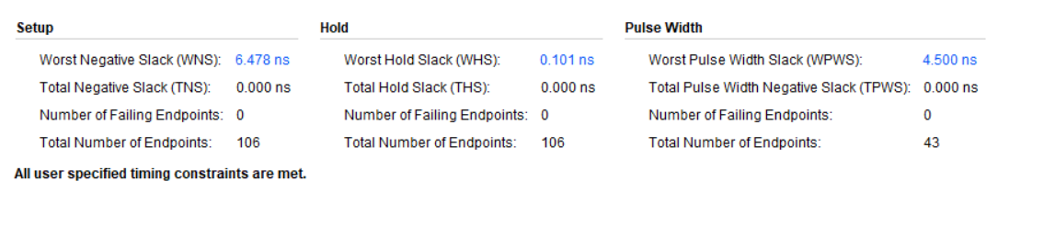

Implementation Critical Path

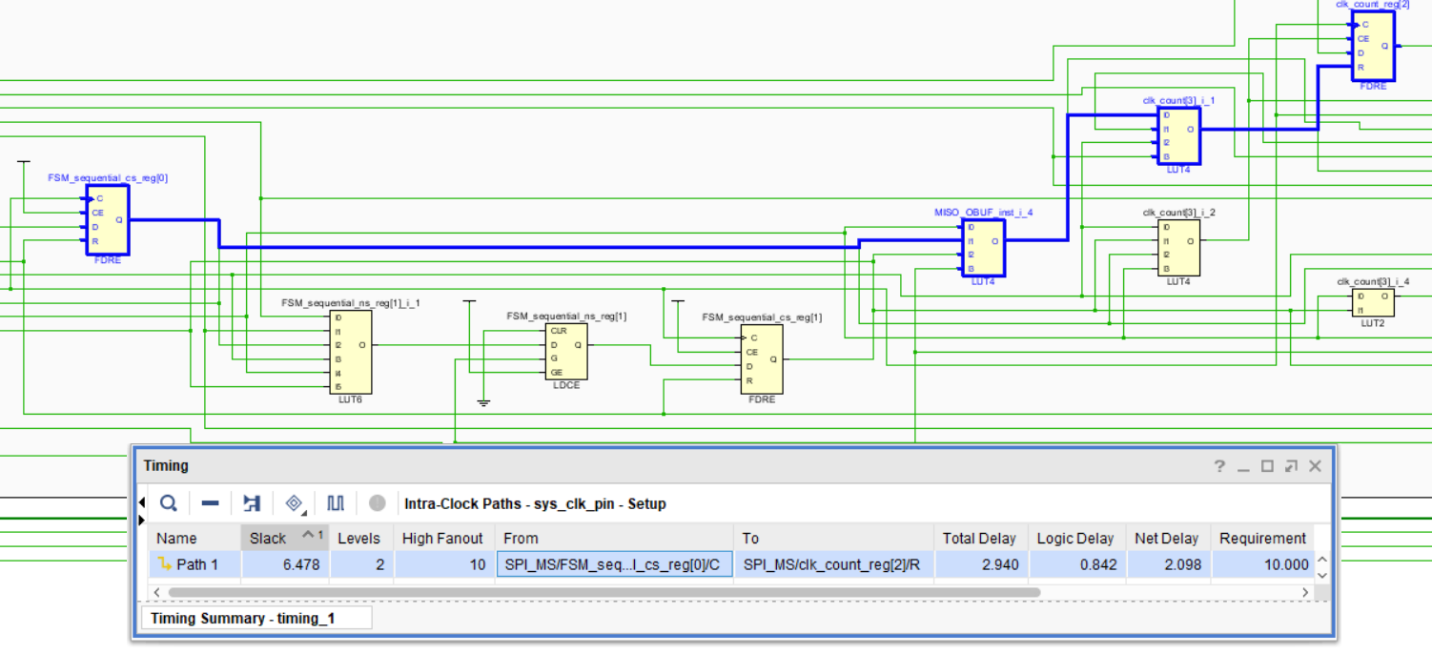

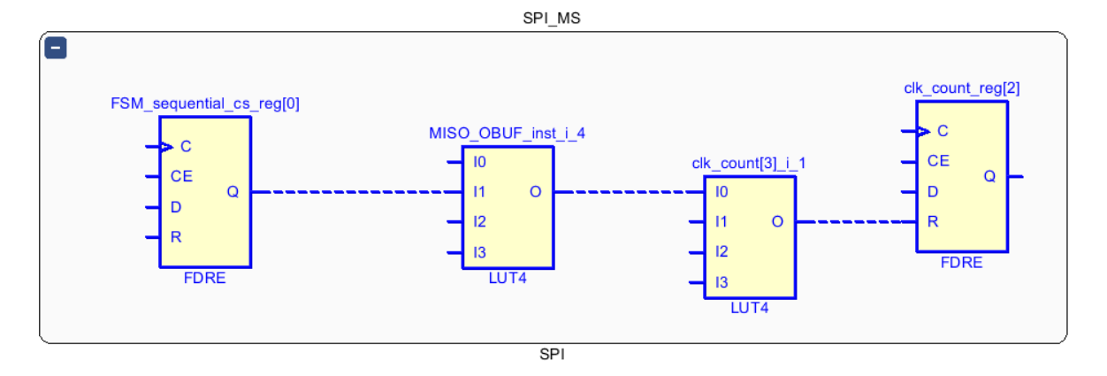

One hot Encoding

Encoding Report

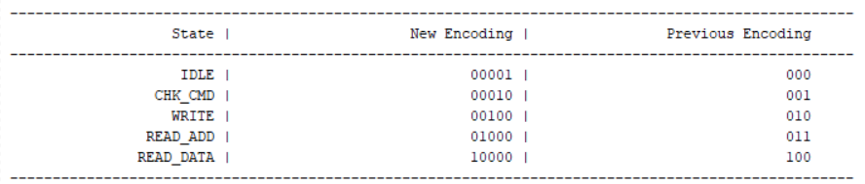

Synthesis Schematic

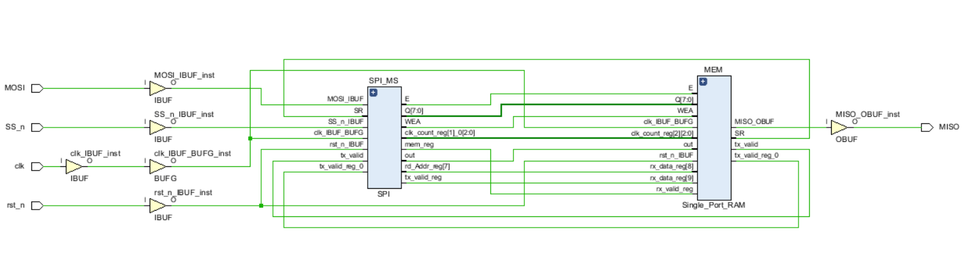

** **

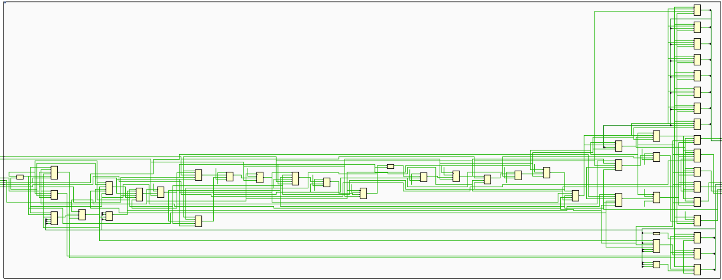

Synthesis Messages Tab

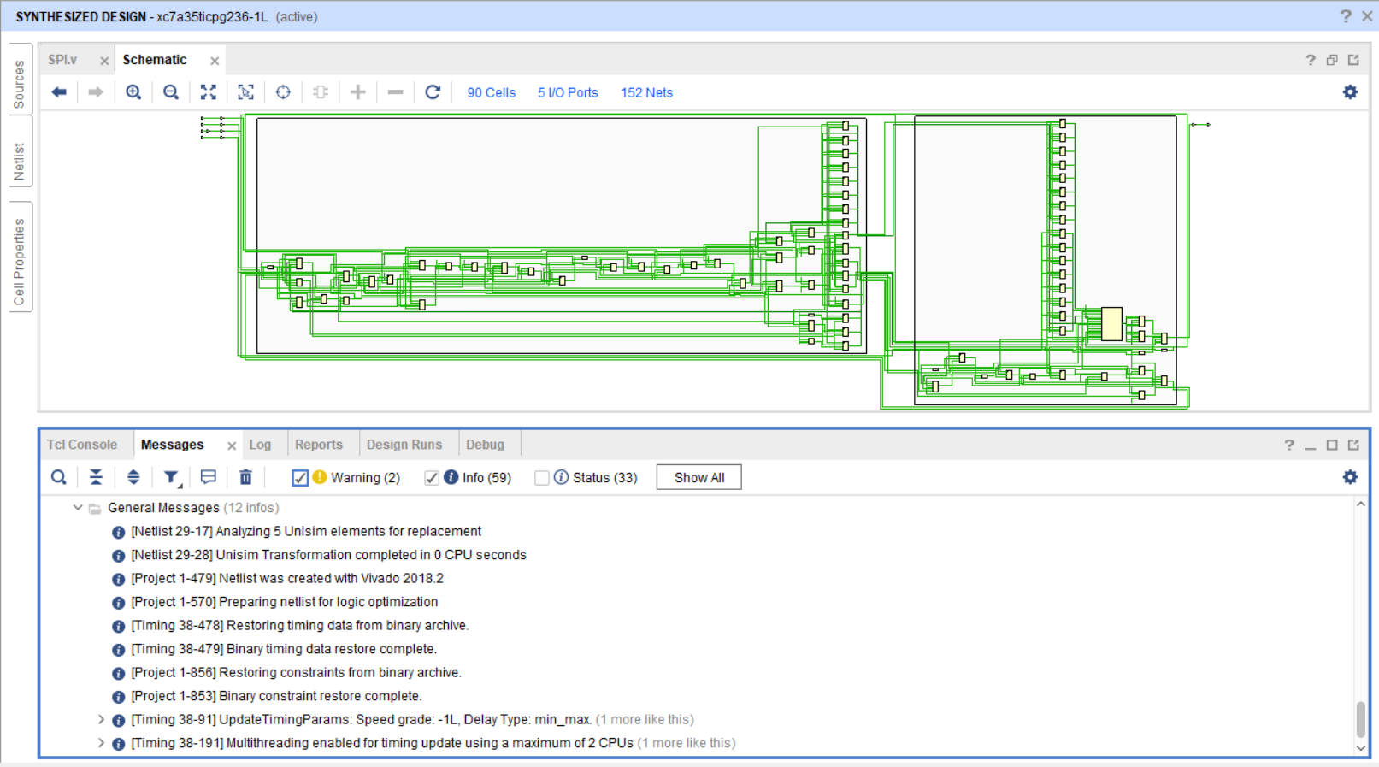

Synthesis Utilization & Timing Reports

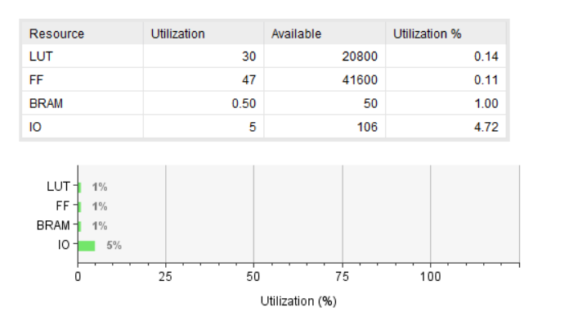

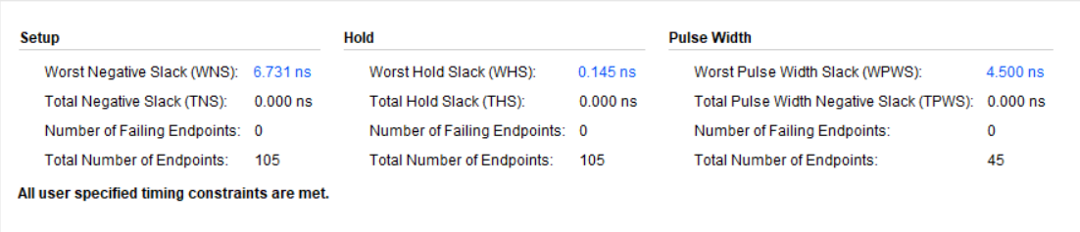

Synthesis Critical Path

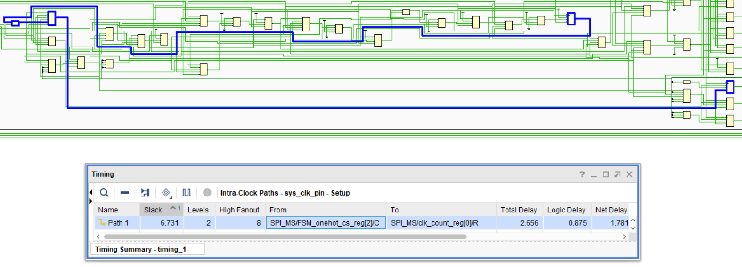

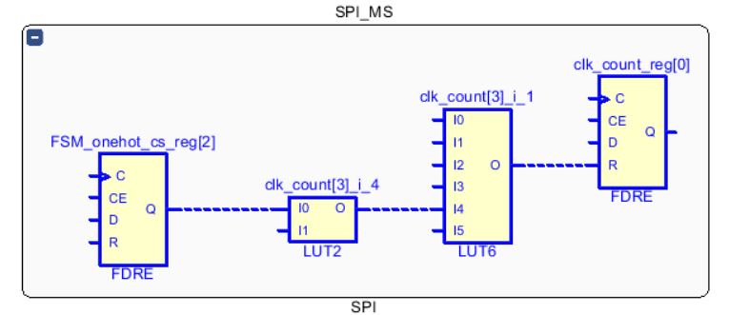

Implementation Messages Tab

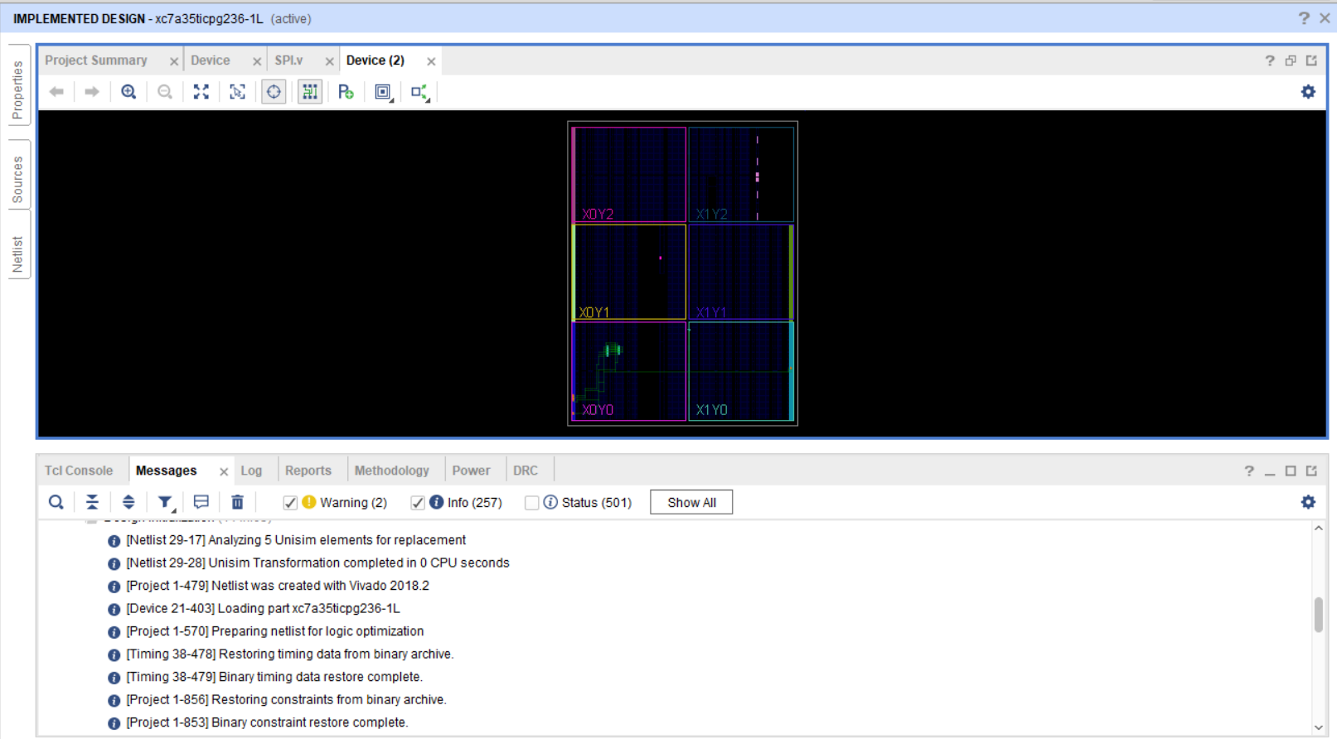

Implementation Device

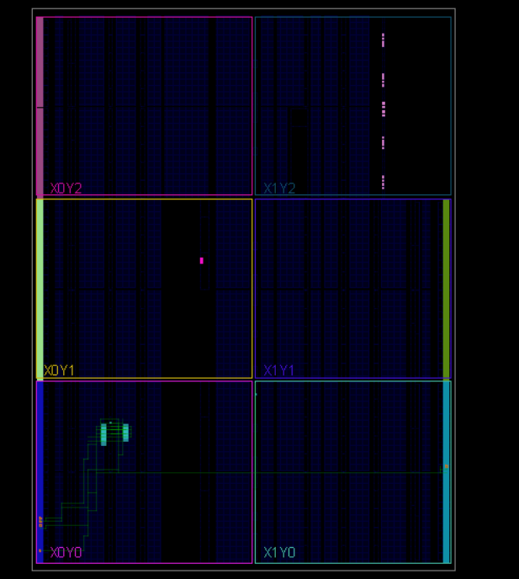

Implementation Utilization & Timing Reports

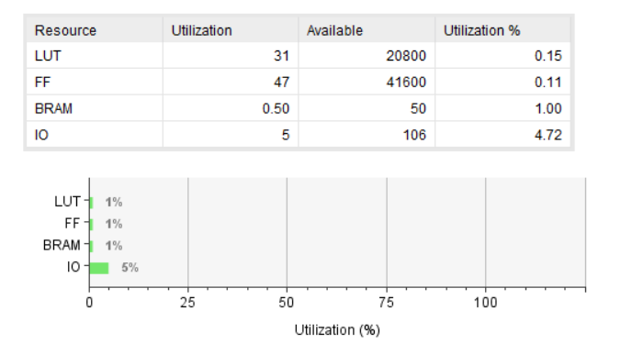

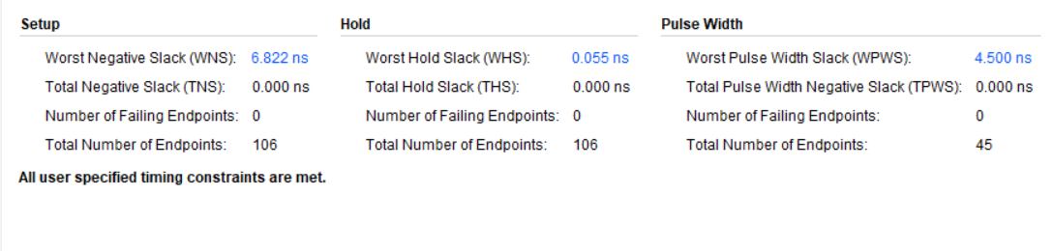

Implementation Critical Path

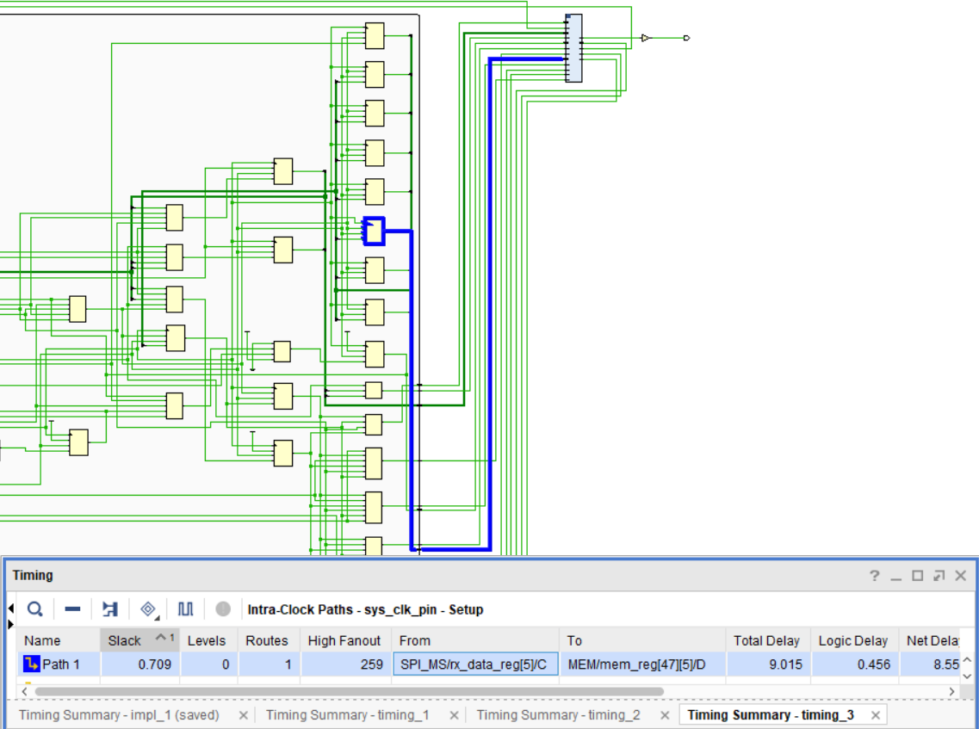

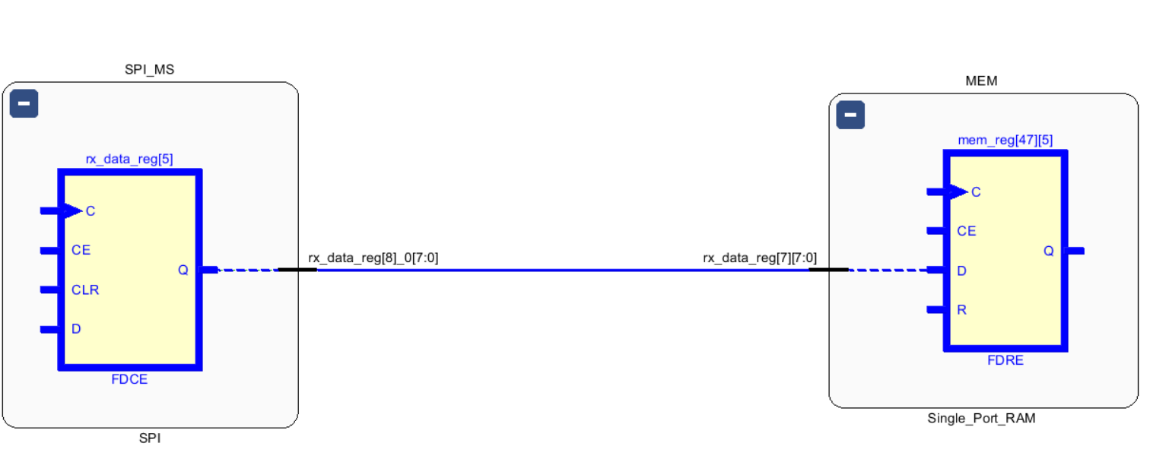

Gray Encoding

Encoding Report

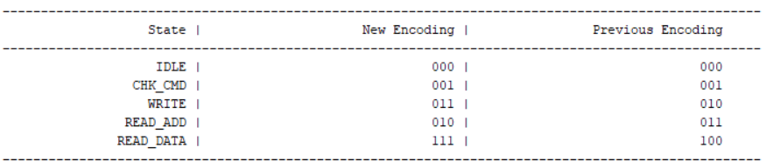

Synthesis Schematic



** **

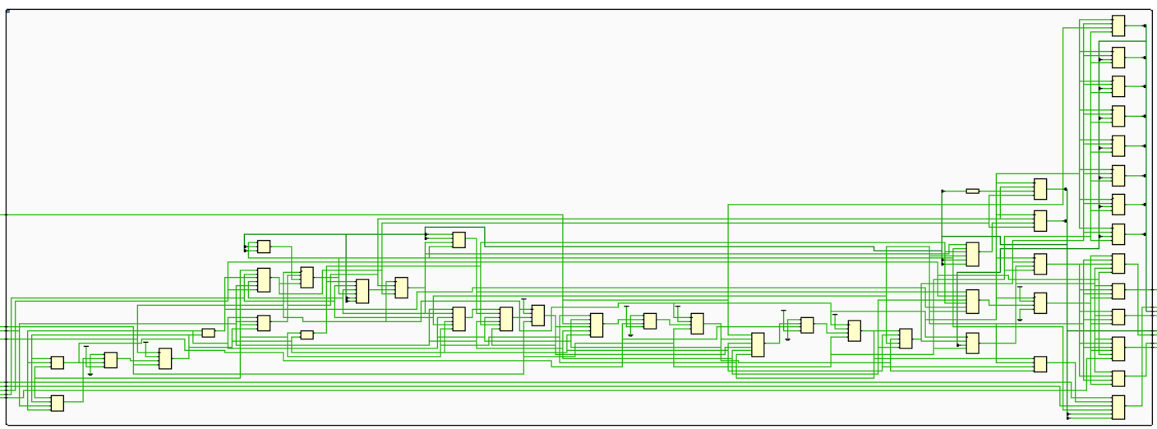

Synthesis Messages Tab

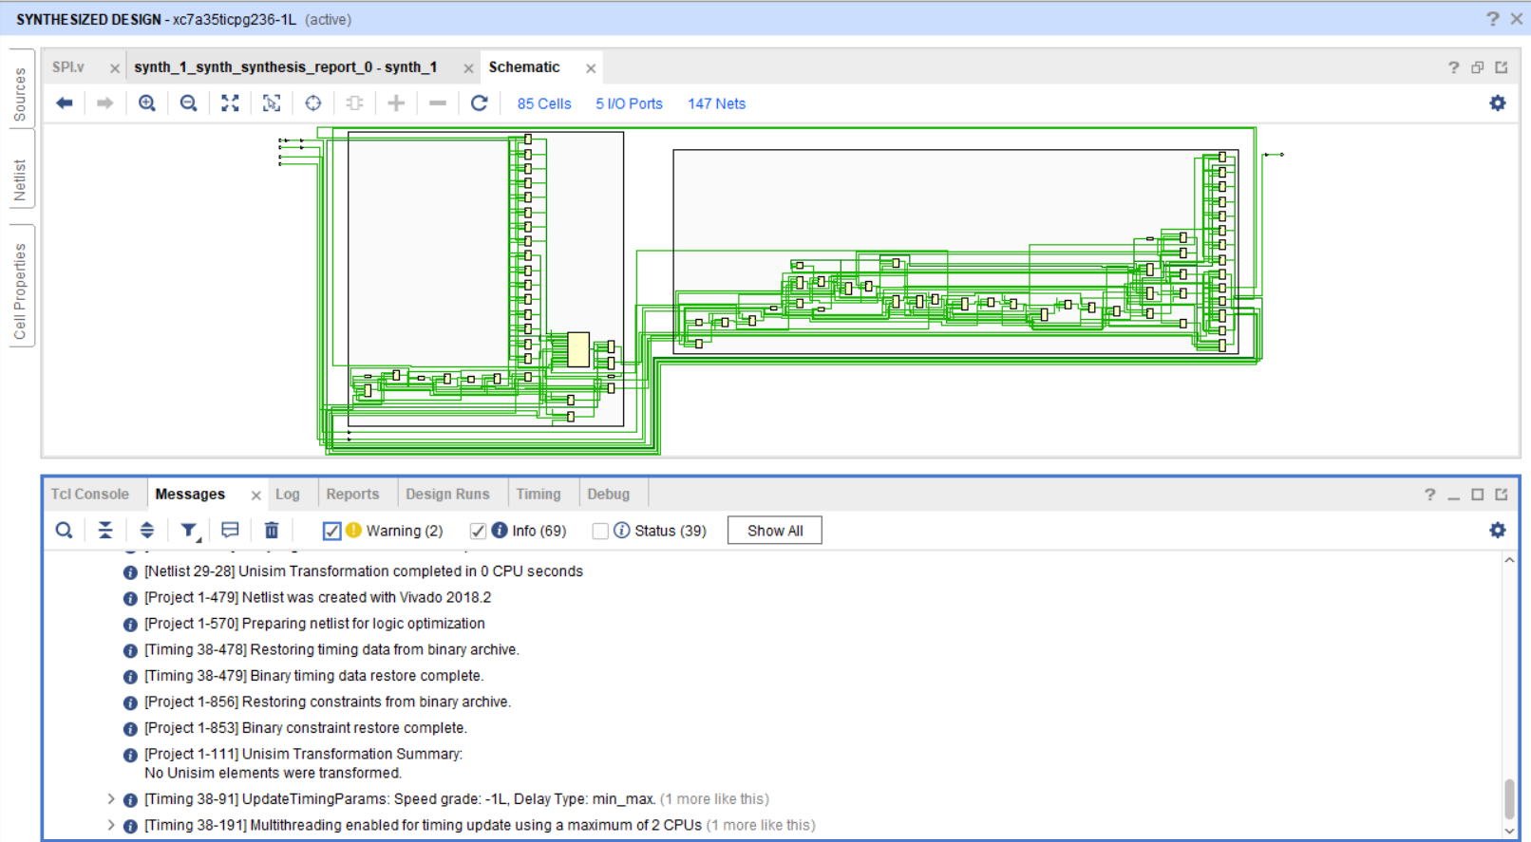

Synthesis Utilization & Timing Reports

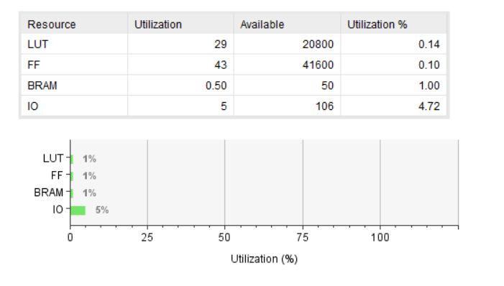

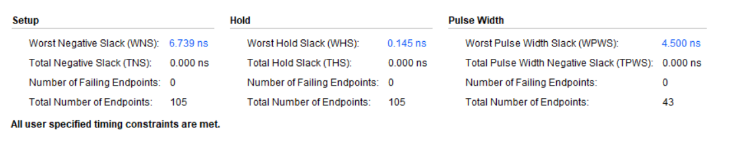

Synthesis Critical Path

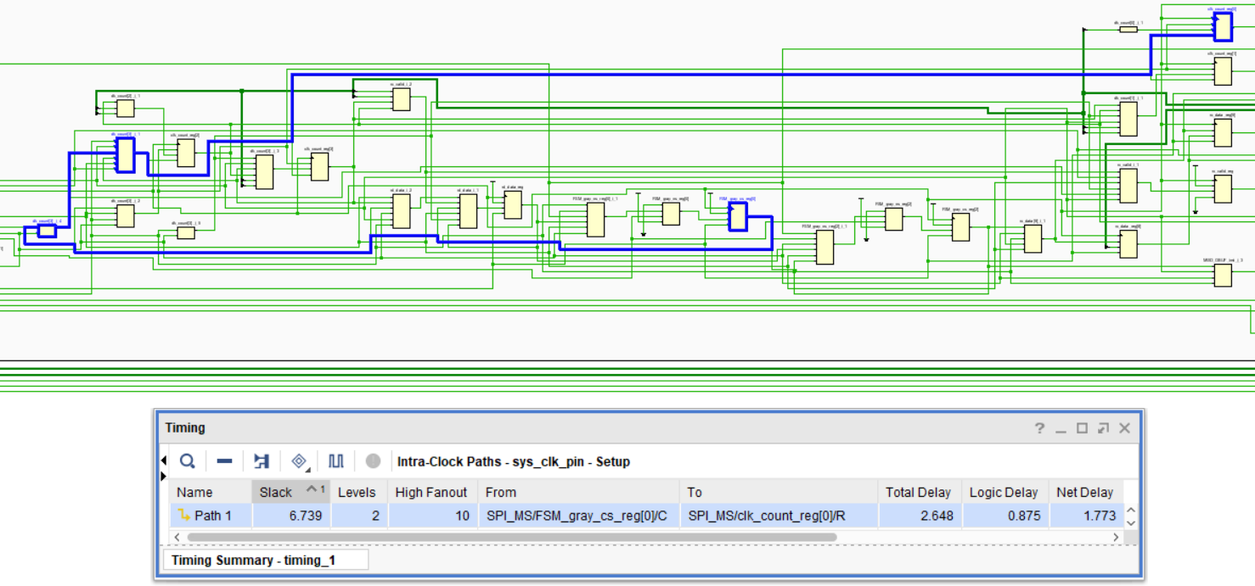

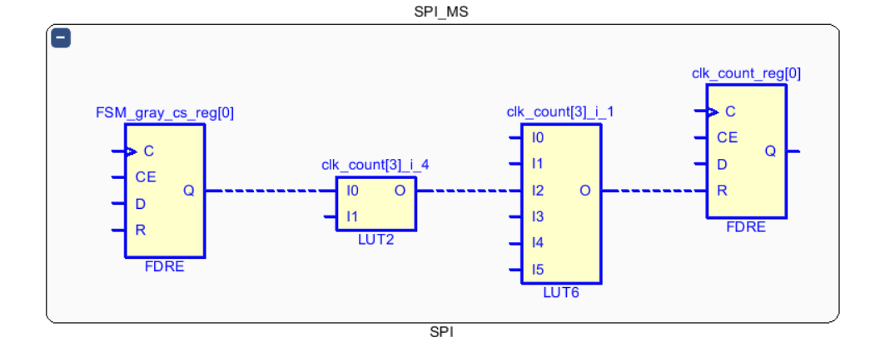

Implementation Messages Tab

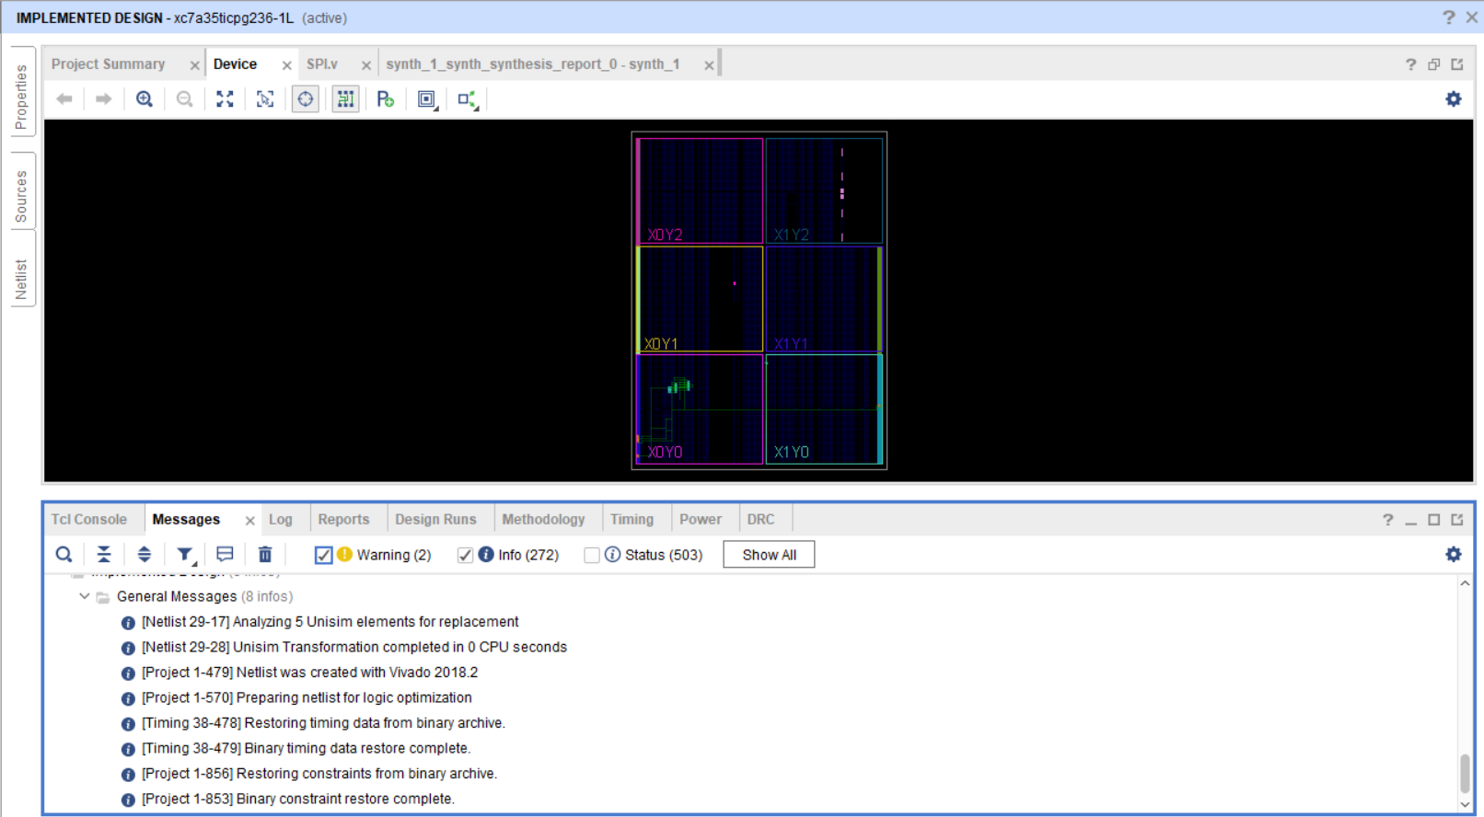

Implementation Device

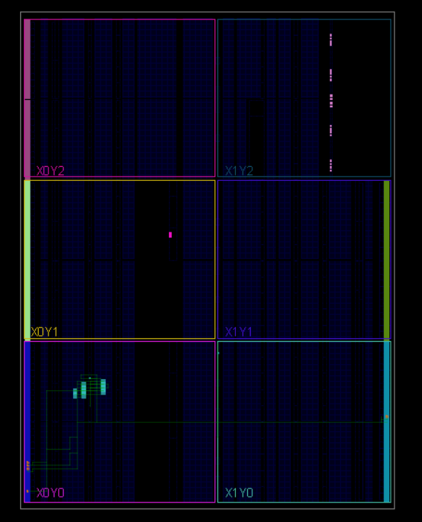

Implementation Utilization & Timing Reports

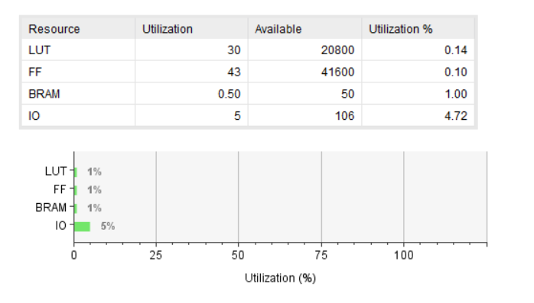

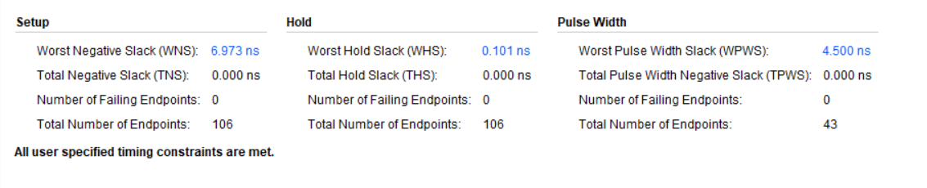

Implementation Critical Path

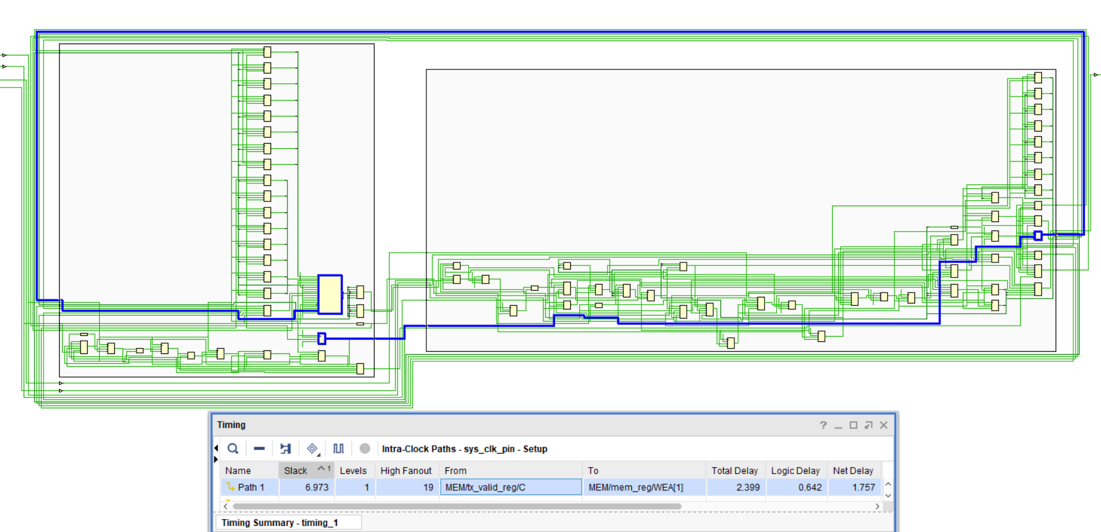

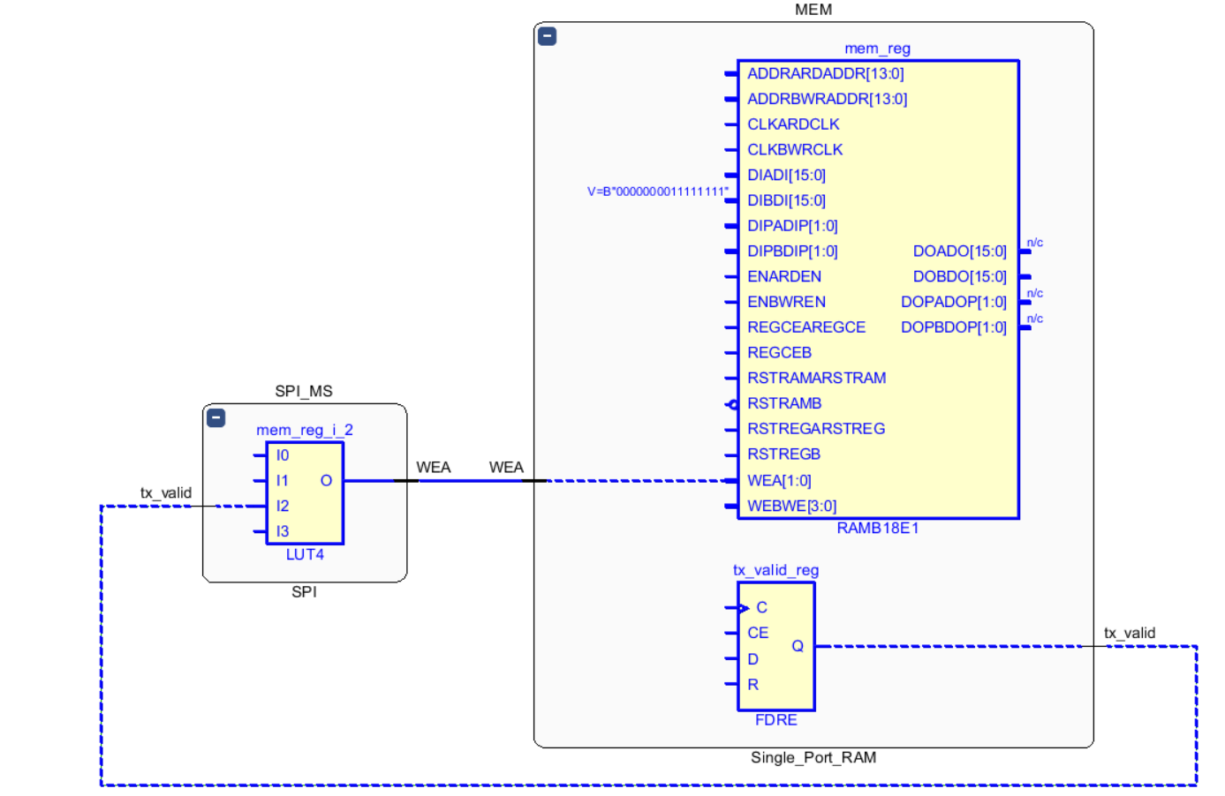

|  |  |  |  |
| --- | --- | --- | --- |
| **Method** | **Setup WNS (ns)** | **Hold WHS (ns)** | **Selected** |
| **sequential** | **6.478** | **0.101** | **×** |
| **One hot** | **6.822** | **0.055** | **×** |
| **Gray** | **6.973** | **0.101** | **✅** |

**Timing comparison of three different encoding implementation methods**

* **Setup WNS = 6.973 ns → Best (means most margin before violating setup constraint → allows highest clock frequency).**
* **Hold WHS = 0.101 ns → Higher than One Hot**

**Conclusion: chose Gray → It gives the best timing margin for maximum frequency operation while meeting all constraints.**

Implementation Message Tab After Debug Setup

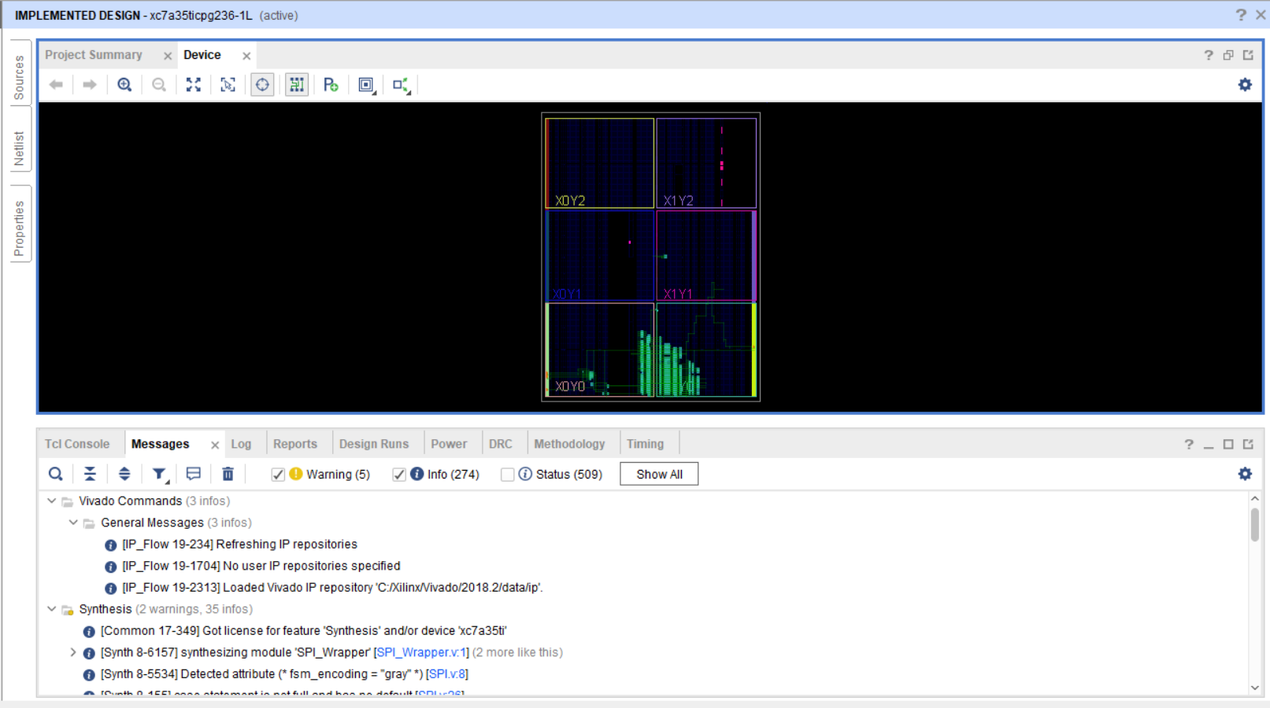

New Device After Debug Setup

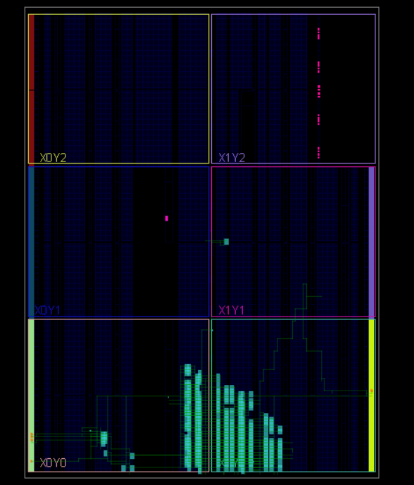

**Implementation Utilization & Timing Reports After Debug Setup**

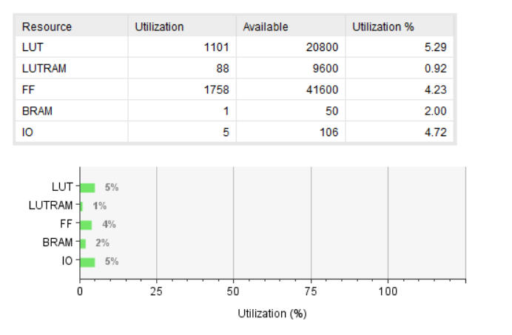

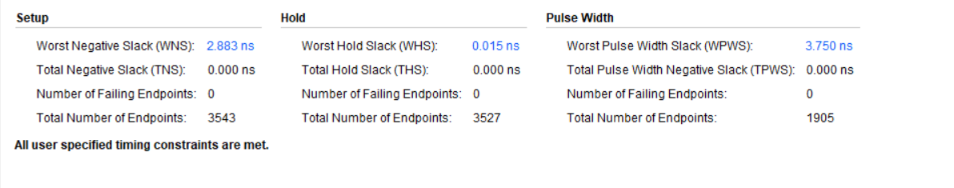

Implementation Critical Path After Debug Setup

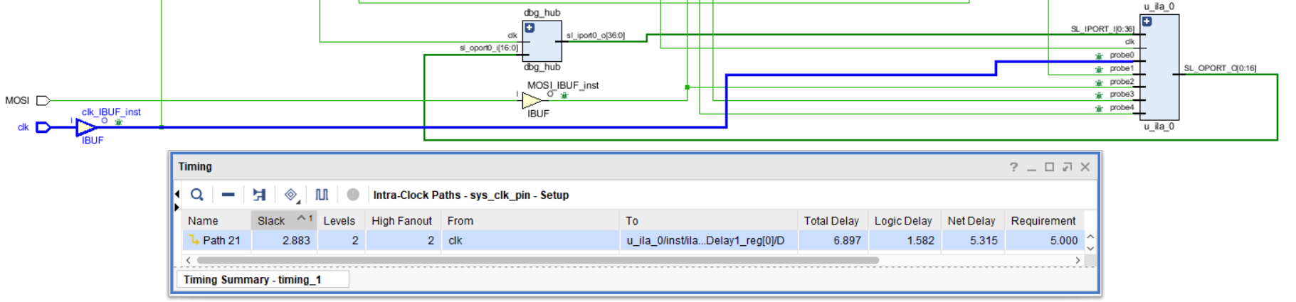

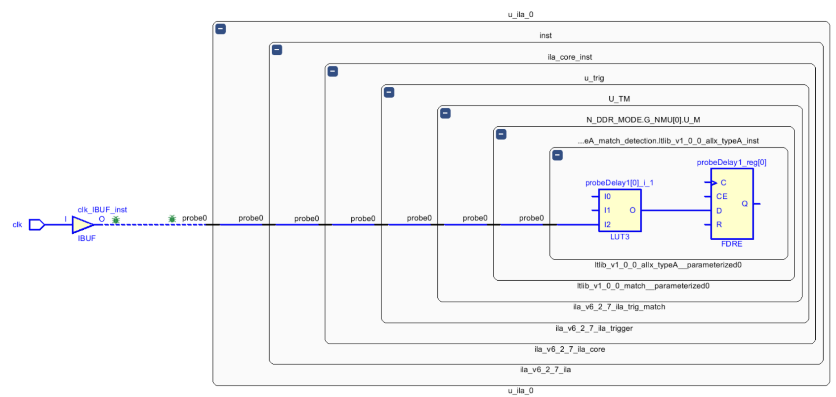

Constraints File

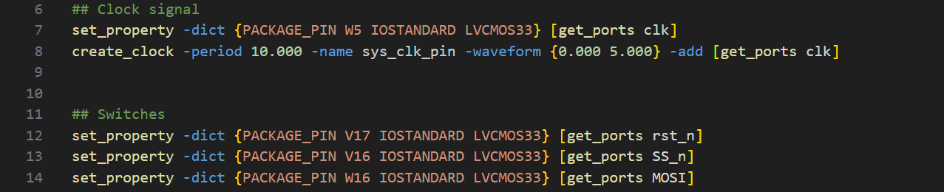

Debug Core Added To Constraints File

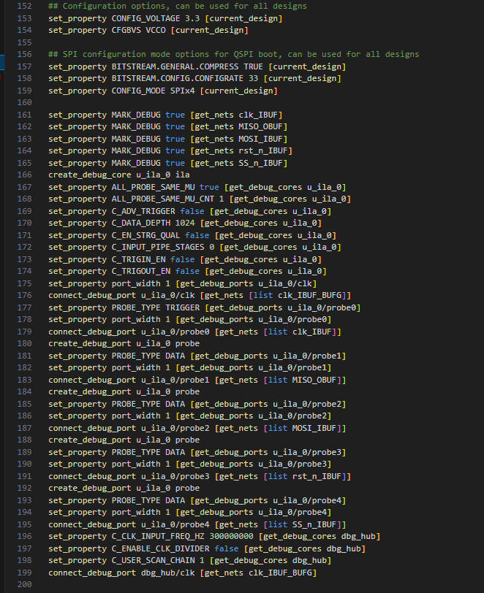

Successful Bitstream Generation

